Graphs

Definition. Directed graph is a pair G = (V, E), where V - a finite set of vertices, E - set of edges, which is defined as a binary relation on V: E ⊆ V × V.
A directed graph is called a digraph. The count may include edges - loops that connect a vertex to itself. About an edge (u, v) is said that it comes from u and is included in the vertex v.
3
1
2
4
5
6

Directed graph
V = {1, 2, 3, 4, 5, 6},
E = {{1, 3}, {3, 2}, {2, 2}, {2, 4}, {5, 6}}

In an undirected graph the set of edges E is ordered pairs of vertices. About an edge (u, v) an undirected graph is said to be incident to the vertices u and v. If the graph G contains an edge (u, v), we say that the vertex u is adjacent to v. For an undirected graph adjacency relation is symmetric.

Definition. Degree of a vertex in an undirected graph is the number of incident edges. For directed graphs there is distinguished input and output verteces; the sum of the input and output powers is called the degree of a vertex.

Definition. If to each edge is assigned a number, then this graph is weighted.

Definition. The adjacency matrix of the graph G (V, E), |V| = n, is defined to be a boolean matrix A n × n, that A[i, j] = 1 if and only if between verteces i and j, there is an edge. In case of a weighted graph adjacency matrix is ​​represented two-dimensional numerical matrix, wherein the A [i, j] equals the edge weight unless between nodes i and j, it exists, and A [i, j] = 0 otherwise.

The adjacency matrix for the graph shown above is as follows:
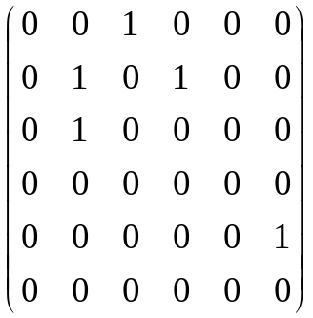

Check of the presence of edges (v_{i}, v_{j}) using the adjacency matrix takes time O(1). Finding all the vertices adjacent to v_{i}, requires O(n) time (it is enough to see the i - th line adjacency matrix).

Statement. The adjacency matrix of an undirected graph is symmetric.
3
1
2
4
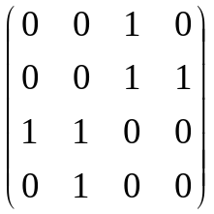

Undirected graph and its adjacency matrix

If the graph contains n elements, for storage of the adjacency matrix must be assigned to the memory of n² elements. If the graph is sparse (contains a small number of edges), the storage of information in the graph adjacency matrix is ​​not effective. To do this, use the adjacency list.

Adjacency list contains for each vertex v ∈ V list of vertices adjacent to it. The number of memory cells required to represent the graph using the adjacency list has order of |V| + |E|.

Example. Announced the list of adjacency g and it is listed in the information on an undirected graph. The first line contains the number of vertices. Each of the following - two vertices are connected by an edge.

Input
4
1 3
2 3
2 4

#include <cstdio>
#include <vector>
using namespace std;

vector<vector<int> > g;
int n, a, b;

int main(void)
{
scanf("%d",&n);
g.assign(n+1,0);
while(scanf("%d %d",&a,&b) == 2)
g[a].push_back(b),g[b].push_back(a);
. . .
return 0;
}

After reading the data state of the vector g is as follows:

g[1] = (3)
g[2] = (3, 4)
g[3] = (1, 2)
g[4] = (2)

If the vertices are numbered starting with 1, the element g[0] is not used for data storage.

Definition. An undirected graph is called simple if it has no loops and an arbitrary pair of vertices is connected by no more than one edge.

Definition. A simple graph is called complete if every pair of vertices is connected by an edge. This graph contains 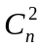 edges.

Definition. The path of length k from vertex u to vertex v is defined as a sequence of vertices (v₀, v₁, …, v_{k}), v₀ = u, v_{k} = v and (v_{i-1}, v_{i}) ∈ E for all i = 1, …, k. The path length k consisting of k edges. Vertex v₀ called the beginning of the path, and v_{k} - its end.
If for given vertices u and v there is a path from u to v, we say that a vertex v is reachable from the vertex u.

Definition. The path is simple if all vertices in it are different.

Definition. Cycles in a directed graph is a path in which the initial vertex coincides with the end and which contains at least one edge. Edge - cycle (loop) is a cycle of length 1. The cycle is simple if it does not contain the same vertex (except the first and last), that is, all the vertices v₀, v₁, …, v_{k} different.

Definition. Directed graph that does not contain edges - loops, called simple.

Definition. In an undirected graph path (v₀, v₁, …, v_{k}) is called a (simple) loop if k ≥ 3, v₀ = v_{k}, and all the vertices v₀, v₁, …, v_{k} different.

Definition. Graph, in which there are no cycles is called acyclic.

Definition. An undirected graph is connected if for any pair of vertices there is a path from one vertex to another. For an undirected graph the relation "to be achievable from" is relation of equivalence on the set of vertices. The equivalence classes are called the connected components of a graph.

